**Matt Paul**

**Jake Andersen**

**Subhashini Venkatachalam**

**Kahwaji Team 10**

**Group Project Report**

**5/1/2024**

**Matt Paul**

**Jake Andersen**

**Subhashini Venkatachalam**

**Group Project Report**

**5/1/2024**

**Detailed Report on Online Customer Churn Using Power BI**

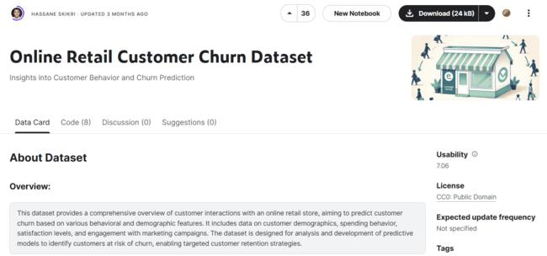

**Overview**

As detailed in the assignment instructions within the CIS-570 Syllabus our group is charged with finding a dataset of our interest on the internet and inserting it into MS PowerBI Desktop. As such we chose a dataset about customer churn for an online retail company. This dataset was found on Kaggle and was titled Online Retail Customer Churn Dataset. We wanted to treat this project as if we had received this data from our company and they want us to determine the cause of customer churn. Our dataset had enough dimensions for a meaningful data model with over 15 columns and 1000 rows which we divided and organized into a “Churn” Fact Table and “Orders” and “Customers” tables with multiple additional dimensions within each table. It also seemed like it would be an intriguing dataset for us to investigate and utilize PowerBi for exploration. In general, we analyzed this data set to explore various factors which contribute to an increase in the rate of customer churn. From a business perspective it was our hypothesis that with this data and our visual representations of it created through PowerBI we could assist the business team in strategizing and help them to plan accordingly to reduce their customer churn and improve their retention.

Before we could get into greater detail the first question we had to answer was: What is churn rate? After doing research online The Churn rate is “the rate at which customers stop doing business with an entity.” (Cheng & Kvilhaug, 2024). Under the Key Takeaways section in this article, it lists the following:

1. The churn rate measures a company's loss of subscribers for a given period of time.
2. Churn rates can be applied to subscription-based businesses as well as to the number of employees that leave a firm.
3. Churn rate is the opposite of growth rate, which measures the acquisition of customers.
4. For a company to experience growth it must ensure that its new subscriptions are higher than its lost subscriptions in a given period.
5. Each industry will have a different average churn rate that companies can compare themselves with to understand their competitiveness.

For us it made sense to start with “the why”. So “why” does churn matter? In completing additional research online, a theme that appeared continuously is that, in general, churn is costly! It is often much more cost effective to retain current customers than it is to attract new ones. This is a general guidepost as to why churn is really important for any company, whether the company is a brick-and-mortar mom and pop or web-based monster corporation. We also realized through this research that the only way a company can actually increase its market share is to retain customers (decrease churn) and attract new customers.

**Our Investigative Questions with Practical Implications**

The primary research goal for this project is to understand which customer attributes contribute significantly to churn in an online retail context. Specifically, our investigation focused on whether demographic factors like age, income, and customer engagement metrics such as the number of purchases and satisfaction levels influence customer retention and decrease churn. Practical implications of these questions include:

* Identifying target demographics that are less likely to churn.
* Enhancing the business’s customer retention strategies.
* Understanding the impact of marketing initiatives on customer loyalty.
* Determine if there are measurable factors that cause or decrease churn.
* Understanding whether satisfaction scores have an effect on churn.



Our thought then is that if we can discover different attributes that lead to decreases in churn, we could direct a company toward customers that are less likely to churn or help to identify activities or methods which help to reduce churn as well. We also theorized that customers who were more satisfied or that had stayed with the company longer would churn less and be more loyal. Again, reducing churn and/or ensuring your new customer enrollment outpaces your churn rate is the only way you can actually increase your customer base. As such churn rate is a critical metric for a business to track and analyze.

Some additional thoughts that surfaced through our investigation are that it seems that producing a better product would also decrease churn. We then proposed that it would be somewhat the same with producing goods that are unique or selling products that are seen as essential. Our next steps after this initial analysis would be to gather data based on our business’s products to see how they stack up to the competition. This would allow us to see if we are losing customers because of an issue with our products.

**Online Retail Customer Churn Dataset Description**

The dataset we used for this analysis is sourced from Kaggle.com at this link: [Online Retail Customer Churn Dataset](https://www.kaggle.com/datasets/hassaneskikri/online-retail-customer-churn-dataset). It includes multiple features such as age, gender, annual income, total spend, years as a customer, number of purchases, and customer satisfaction scores among several others. This dataset was chosen for its comprehensive range of metrics that allowed for a multi-dimensional analysis of customer behavior, retailer behavior, and churn. The data pertains to an online retail setting. We were interested in this and found it specifically relevant given the increasing shift towards e-commerce worldwide and an understanding that in this particular channel of consumer engagement customer retention is crucial especially since there is less physical customer interaction.

**Online Retail Customer Churn Raw Data Dictionary**

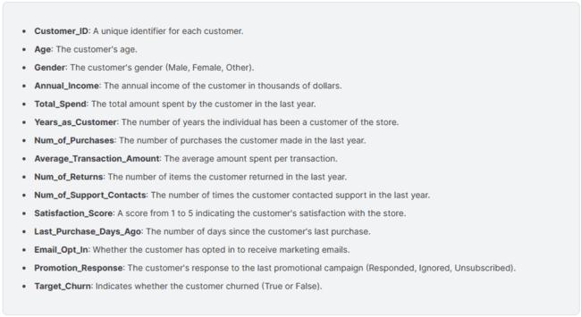

Above is a screenshot directly form the Kaggle site where this information was accessed. Below is the full description of these dimensions as detailed above and with some additional information and description related to each of them added as well.

* **Customer_ID**: This is a unique identifier for each customer. This was the primary separation dimension for our customers before we delved deeper into demographic data.
* **Age**: This refers to the customer's age.
* **Gender**: This refers customer's gender (Male, Female, Other). We found that we had a large number of customers that chose “other” perhaps indicating that many customers chose not to share this information.
* **Annual_Income**: This refers to the annual income of the customer in thousands of dollars. This dimension was expanded through our exploration and data cleanup to show the actual dollar amount (value given x 1000 and data type changed to $).
* **Total_Spend**: This number refers to the total amount spent by the customer in the last year. This data was expanded and cleaned up for clarity as well.
* **Years_as_Customer**: This refers to the number of years the individual has been a customer of the store.
* **Num_of_Purchases**: This refers to the number of purchases the customer made in the last year. This was cross referenced with the Total_Spend dimension to do some of our investigations and reveal information regarding actual transaction amounts.
* **Average_Transaction_Amount**: This refers to the average amount spent per transaction. In contrast to the actual number of transactions this dimension is broke down by number of purchases divided by the total amount spent.
* **Num_of_Returns**: This refers to the number of items the customer returned in the last year. It did not, however, contain information related to the dollar amounts or even averages of the cost of the items that were returned.
* **Num_of_Support_Contacts**: This refers to the number of times the customer contacted support in the last year. There was no further data related to the time the customer spent conversing with support or whether or not support was able to resolve their issue.
* **Satisfaction_Score**: This refers to a score from 1 to 5 indicating the customer's satisfaction with the store. It was inferred that customers who were more satisfied would have churned less than customers who were less satisfied.
* **Last_Purchase_Days_Ago**: This refers to the number of days since the customer's last purchase. This dimension helps us to understand when the customer last engaged with the online retailer.
* **Email_Opt_In**: This refers to whether the customer has opted in to receive marketing emails. It was also inferred that those who had opted in may be more committed than those who hadn’t which could be an indicator of loyalty and product buy-in which could have an effect on churn.
* **Promotion_Response**: This refers to the customer's response to the last promotional campaign. The options offered to the customer within this dimension were: “Responded”, “Ignored”, and “Unsubscribed”. We theorized that those who “Responded” were less likely to churn, those who “Ignored” would be evenly distributed, and those who “Unsubscribed” may be more likely to churn.
* **Target_Churn**: This indicated whether the customer churned (True or False). If the customer value for this dimension is “True” then the customer has left the retailer and therefore “churned”. If the customer value for this dimension is “False” then the customer has not left the company.

All of the above represent how the data initially imported into Power BI for us from the original dataset. Below you will see how we modified the data to become more useful throughout our exploration and for our visuals.

**Diving into Data Discovery**



The above raw data for online retail customer churn has been used for this analysis. We downloaded and modified this data to see if we can detect trends that will help us reduce the churn and improve customer retention.

**Data Preparation**

In order to prepare and clean up the data we downloaded the dataset and uploaded it into Power Bi. We then transformed the data using power query. We used power query to transform the raw data into a fact table (churn) and into two separate dimension tables (customer and orders). We then renamed the data columns for clarity and usability and created an Income Range, Years as Customer Range, and Age Range columns so that we could create better visualizations. As stated above we also adjusted annual income to show full dollar value not a whole number in thousands. This allowed for a clearer and more honest picture of this particular dimension. We then changed the data types when necessary to ensure measures and calculated columns were computed correctly. Since our data set started as just one large table and needed to be broken up into fact and dimension tables, we also had to specify relationships between the tables to ensure that we could produce the necessary calculations, measures, and visuals. As such we used the Customer_ID as the key to tie our tables together. This allowed us to develop measures and calculations that could count the number of people who churned in each demographic. Since our churn data is in true false format, meaning it says true if the person left, we created some measures to count the number of true (leaving) and number of false (staying). This is how we derived our actual percentages and numbers for the customers that have churned over within this data. We also produced counts for email responses so we could have a numerical factor to utilize regarding how many email responses had been given. This allowed us to relate this factor to other columns. We also calculated the following calculated columns and measures:

* **Age Range:** This was to allow us to summarize the amount of churn by age. We wanted to find which customer age range was least likely to churn so we could recommend a target demographic for marketing efforts.
* **Income Range:** This was to allow us to summarize the amount of churn by income. We wanted to find which customer income range was least likely to churn so we could recommend a target demographic for marketing efforts.
* **Years as Customer Range:** This was to allow us to summarize the amount of churn by years as a customer. We wanted to find out if years as a customer affected churn so we could recommend a loyalty program tailored to growing that customer group.
* **Avg # of Purchases:** This shows how many purchases on average a customer or group of customers made. We wanted to find if customers who purchase more often are more lease likely to churn to determine if the business should market more frequent smaller orders.
* **Avg Days Since Purchase:** This shows on average how many days it has been since the last purchase a customer or group of customers made. We wanted to find if customers whose last purchase was a longer time ago were more likely to churn. If so, this could indicate that more frequent marketing emails/promotions would encourage more frequent orders and therefore less churn.
* **Avg Returns:** This shows on average the dollar value of returns this customer or group of customers made. We wanted to see if customers who return larger amounts of items were more likely to churn which would indicate that product quality is causing churn and efforts should be made to improve product quality.
* **Avg Satisfaction:** This shows the average customer satisfaction of a customer or group of customers. We wanted to see if customers with higher satisfactions were less likely to churn.
* **Avg Spent:** This shows the average dollar amount that a customer or group of customers spent in the last year. We wanted to see if the customers who purchase the most are less likely to churn.
* **Avg Support Contracts:** This shows the average number of times a customer or group of customers contacted customer support. We wanted to see if our businesses customer service on product support was causing customers to churn.
* **Median Days Since Purchase:** This shows the median number of days it has been since the last purchase a customer or group of customers made. We wanted to confirm that our average number of days wasn’t being skewed by customers with incredibly long times since their last purchase.
* **% Staying**: This shows the percentage of customers who didn’t churn in the last year. We wanted to use this as a value to see how likely customers were to stay.
* **Count of Leaving:** This shows the number of customers who churned in the last year. We wanted to use this as a value to see how many customers left. It also allowed us to see the significance of various customer groups.
* **Count of Stay:** This shows the number of customers who didn’t churn in the last year. We wanted to use this as a value to see how many customers stayed. It also allowed us to see the significance of various customer groups.
* **Count of Email Opt-in:** Our email opt in column was a true false column, so this measure counts the number of customers who opted in to marketing emails. We wanted to use this to see how likely someone was to churn if they were seeing frequent marketing emails.
* **Count of Email Opt-out:** Our email opt in column was a true false column, so this measure counts the number of customers who opted out of marketing emails. We wanted to use this to see how likely someone was to churn if they weren’t seeing frequent marketing emails.

**Our Data Model in Power BI**





The data was structured into a star schema comprising one fact table (**churn**) and two separate dimension tables (**customer** and **orders**). Here's the arrangement:

* **Fact Table**: Churn (with a binary indicator showing true for churned customers and false for retained customers)
* **Dimension Tables**:
  + Customer (attributes like age, gender, income, etc.)
  + Orders (details about customer orders such as transaction amounts and number of purchases)

This model supported efficient querying and aggregation, allowing for deeper insights into the churn patterns based on varying attributes.

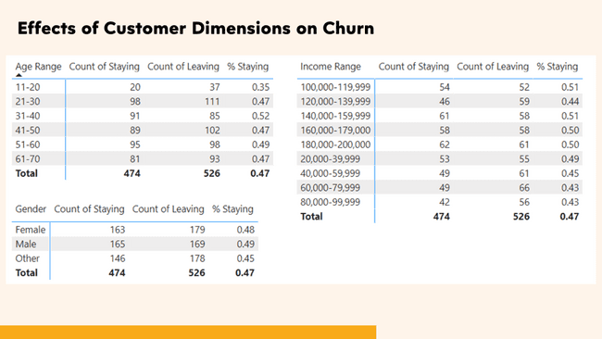**PowerBI Visualizations/Dashboards**

We first wanted to answer the question which customer demographic affected churn. We first produced a number of matrixes to see the effect of age, income, and gender on churn rates. We found that customers who were 31-40 were 5% more likely than average to stay but because of our smaller sample size there was no significant change in percentage of churn across age ranges, besides for the 11-20 yr. old age range. They were the most likely to churn with only 35% of them staying. We see no significant difference in churn rates across gender. We found that for income ranges of 100-120k and 140-160k they were 4% more likely to stay. While income ranges of 60-80k and 80-100k were 4% less likely to stay than average.

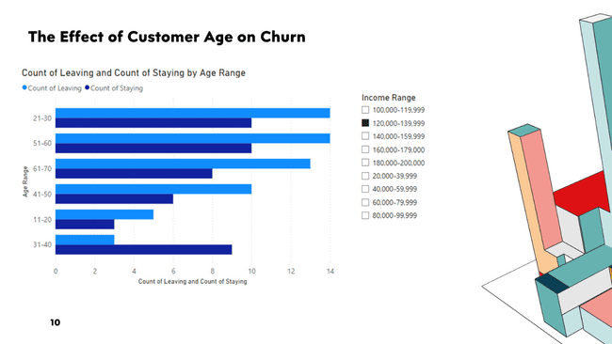

We then wanted to look at if age and income played any combined effect on churn so we included a Slicer with a clustered bar chart so that we could slice the data as we made predictions regarding how different incomes would affect churn for the various age ranges. Specifically in this case, we were seeking to discover if an income of 120-140k had a strong correlation on age ranges and churn. We found that 31-40 years olds with an income of 120-140k were less likely to churn. However, our sample size was too small for it to be significant.

Next, we explored how email opt-in/opt-out and responses to the last promotional campaign affected churn. We hypothesized that the customers who opted out of emails and still received a promotional email would be the most likely to churn. We also thought that customers who opted-in to emails would be the least likely to churn. However, there seemed to be no significant affect on churn related to email opt-in/opt-out and response to the last promotion.

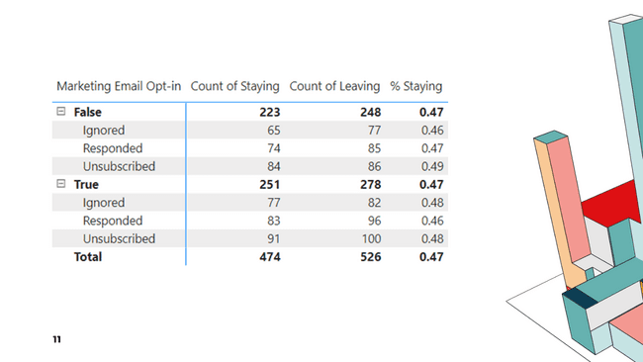

For the next visualization we wanted to explore the effects of customer satisfaction on churn. We hypothesized that the customers who were the most satisfied would be the least likely to leave. In attempting to answer what is customer satisfaction’s effect on churn we found that customer satisfaction doesn’t seem to affect churn. In fact, customers who selected 4 out of 5 in the customer satisfaction survey were the ones most likely to churn. The churn rate was only different by 1% between people who responded 1 and those who responded 5. This made us wonder why that could possibly be so we compared average sales and sum of purchases to customer satisfaction thinking that customers who were more satisfied should probably spend more than those who weren’t. What we found is that customers who were the most satisfied actually spend the least in total purchase dollars. This probably indicates again that there may be validity errors in our customer survey. Clearly, the survey doesn’t seem to accurately track how satisfied people are with the product/company. As part of our recommendation to this business we would recommend that they change their survey to one that is more valid.

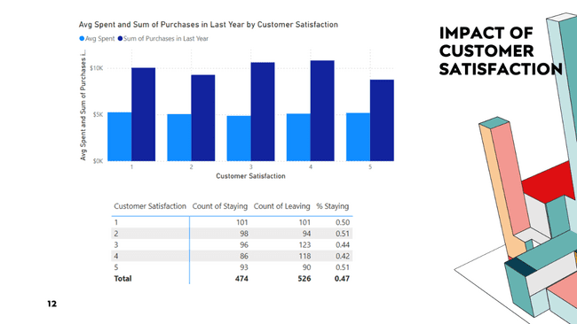

Since it is clear that satisfaction data probably isn’t accurate or at least doesn’t indicate churn we next asked whether dollars spent could act as an indicator for churn. We built some matrices to compare churn across purchases, returns, and support contacts. The matrices below display trends in customer engagement. What we are looking at specifically in the matrix on the bottom of this visualization is the purchase frequency and average transaction amounts compared alongside churn rates. At the top we compare the average transaction amount and sum of total purchases for the previous year in relation to customer satisfaction. What we found is that churn is relatively constant across all those measures. However, customers who churn are slightly more likely to purchase a higher dollar amount of products. They are also slightly more likely to contact support and their median days since last purchase is longer. Those who churn also purchase more products and return more products although their average number of returns is the same as those who don’t churn. However, all these trends are quite small and likely hold little to no statistical significance. We thought that these variances could be due to outside competition from other firms. Meaning that customers aren’t leaving because of dissatisfaction with our business' products but rather because an outside firm provides a product that they prefer.

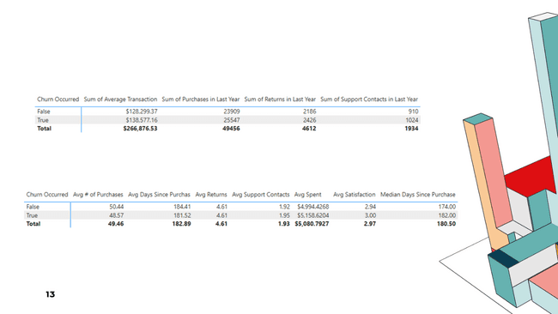

This led us to our next question. We thought that if customers are leaving because they prefer an outside product that we would see a lower churn rate for customers who have been with us longer. Another dimension we felt worth exploring was whether the more loyal customers of this online retailer churn less often than those who are new. We built donut charts to look at customer churn compared to years as a customer. We also looked at if years as a customer affected satisfaction. This was one area where this is a correlation between years as a customer and churn. Those who had been with the retailer between 16-20 years churned the least. Interestingly those who had been there 6-10 years churned at just over 26% and those who had been there 11-15 years churned at just under 26%. The newest customers, who had been there between 1 and 5 years had the highest churn rate, which just exceeded 30%. Showing that once a customer has been with our business long enough that their churn decreases. However, there didn’t seem to be any correlation between customer satisfaction and years as a customer. This lends further collaboration to the hypothesis that the satisfaction survey isn’t valid. This obviously warrants further exploration.

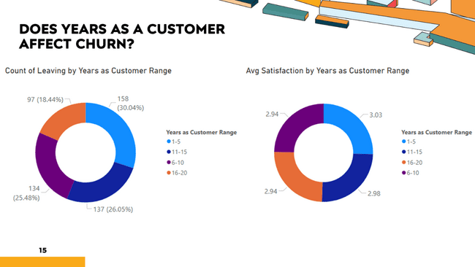

For the last visualization we looked at customers divided by Gender and at the dimension of Years as a Customer. We are trying to answer the question of whether there is a demographic that makes up the customers with the most years as a customer. Since customers who stay with us 16-20 years are less likely to churn it would be beneficial to try to recruit more of this type of customer. We found that women make up a large number of the customers who reach 16-20 years with our business.

However, almost one third of the customers have identified their Gender as “other”. While this may be accurate it is not in alignment with typical gender distributions in the United States, at least according to one source we found online which showed the amount of those identifying as “non-binary” as around 1.6%. (de Vise, 2023). While it is possible that 1/3 of the customers of this online retailer are neither Male or Female it is most likely that within this dataset they simply chose not to identify as either. This makes the usability of this information less reliable or useful from a demographics perspective in allowing us to make predictions and theories regarding causes of churn.



**Analysis of our Results**

The analysis yields several intriguing insights:

* **Demographic Indifference**: Surprisingly, traditional demographic factors like age, gender, or income do not seem to display a significant impact on churn within this dataset. This may suggest that other unexplored factors might be influencing customer loyalty.
* **Counterintuitive Purchase Behavior**: Customers who purchase more frequently are also more likely to churn within this dataset. This might indicate issues like customer fatigue or dissatisfaction with product variety over time. That said these are simply theories that warrant deeper investigation in order to figure out if they are truly valid and reliable results with something meaningful tied to them or simple anomalies within our dataset.
* **Long-term Customer Behavior**: There is a noticeable trend where churn decreases among customers who have been with the company for longer periods (over 16 years), suggesting that long-term customers tend to stick around longer. This could be due to the hassle of switching to a new retailer or possible legitimate brand loyalty. This was one of the only areas where we found strong correlations between dimensions and churn.

**Conclusion**

This study reveals that churn in this online retail environment is not heavily influenced by the typical demographic or transaction-based metrics that we originally expected it would be. Since these findings were completely opposite of what we expected this essentially proves our initial hypotheses, inferences, and theories were incorrect. This insight shifts focus towards potentially exploring more about the customer experience and product offerings as well as causing us to take a deeper look into the data itself. The realization that customer satisfaction isn’t higher with long term customers could lead one to believe that they are leaving the firm and finding a new place to purchase products is simply too much of a hassle, so those customers just choose to stick around simply out of convenience. There is also the potential that our longer-term customers do truly have substantial brand loyalty and therefore are not interested in seeking out alternatives. We see this evidenced in that churn is over 30% for customers who have been purchasing from this online retailer for between 1-5 years and it falls to around 18% for customers that have been purchasing for 16–20-year range.

We revealed time and time again with our data that there weren’t many obvious or any extremely strong correlations within the data dimensions that give us a clear and full insight into the root causes of customer churn. One thing that pops out as a possible reason for this is that we do not have access to the deeper context for this online retailer. This was a dataset chosen off Kaggle.com regarding a topic that we were interested in fairly early in the semester. We chose this before we really knew what to look for in a great data set. While we were still able to glean some interesting insights and it was still useful to use our newfound skills there were definite limitations within this dataset that we may have noticed earlier if we had chosen it later in the semester. In regard to the context, it is clear that we do not understand the products that this company sells. Since we don't know anything about the actual company, we are not able to research further and therefore are not able to delve deeper into the company to ferret out additional information which could lead to possible solutions or an uncovering of additional data that could inform deeper insights.

As we dug through the data and built our visualization it became apparent that without a further ability to analyze this business and understand who they are, who they are trying to market to, or even what they sell it is difficult to make deeper determinations of what might be causing churn let alone to attempt to determine ways to mitigate additional churn moving forward. The incongruence of the data with seemingly common sense coupled with the above realizations about lack of context have also led us to believe that this data may simply have been manufactured specifically for something like a project, etc. and may not be related to a real-life retailer or real-life customers. This could explain why nearly any dimension we investigate shows no strong correlation one way or another and never even begins to reveal anything that could be considered causal for customer churn. Even seemingly simple inferences into probable customer behaviors such as “those who are more satisfied should churn less” turned out to be false when the data was compared in ways that would theoretically be meaningful.

If we were to be able to delve deeper into the business and additional data further investigations might include qualitative studies on customer satisfaction or competitive analysis to understand why even satisfied customers might choose to leave. While this would undoubtedly reveal additional information and allow us to determine causal factors and then potential remedies, we are unable to produce these deeper investigations with this data set. While I would say we are somewhat dissatisfied with the dataset that we chose this analysis underscores the complexity of customer retention strategies and the need for robust, provable, and verifiable data to be the base for anything that can be used for making important decisions. If companies can reveal reliable trends from reliable data, they are laying the groundwork for innovative approaches to understanding and predicting customer behavior and thus figuring out how to modify it toward a positive and profitable outcome.

While the data itself presented limitations, and revealed our personal limitations in dataset selection, the project as a whole proved a great success as we were able to navigate within Power BI and create visualizations that at least represent the data, even if the data doesn’t represent what we expected. Being able to choose a dataset from an actual business that we had experience with would have been helpful as we could have verified the data and compared it to other similar datasets for that company and for others within the same industry. All that aside, customer churn was a topic that clearly piqued our interest. Undoubtedly, we learned a lot about churn, a lot about Power BI, and even more about the importance of finding good, reliable, verifiable data to work with in the BI realm moving forward. While the results were not as expected they were still valuable for us from a learning standpoint, and we are grateful to have embarked on this project and through this course.

**References:**

Eskikri, H. Online retail customer churn dataset. Kaggle. (2024), from <https://www.kaggle.com/datasets/hassaneskikri/online-retail-customer-churn-dataset>

Cheng, M., Kvilhaug, S. (Updated 2024). Churn rate. Investopedia. <https://www.investopedia.com/terms/c/churnrate.asp>

De Vise, D. (2023). New studies find millions of young nonbinary and transgender Americans. *The Hill*. <https://thehill.com/changing-america/3811406-new-studies-find-millions-of-young-nonbinary-and-transgender-americans/>